DDG Newsletter – August 2022 | 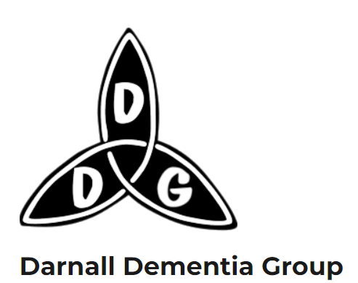

Hello everybody!
Welcome to the second edition of our new newsletter for carers, members, staff and friends of Darnall Dementia Group.
DDG Groups for carers
We continue to offer two groups for carers past and present. Bev runs a fortnightly Zoom group on Tuesdays 2pm - 3pm which is a chance to catch up on the week’s events and is well attended. Please call Bev for the Zoom links and log ins.
Ayesha runs a monthly face to face carers group from one of the upstairs rooms at St Albans. It’s a chance to share how we are all getting along but also a chance to share news about groups, events and useful tips. It’s also a chance to meet without the person you care for as they are able to come to a fun (and free) singing session with Andrea downstairs in the Day centre – even if it’s not their regular day to attend. We may be able to help with transport for those living near to Darnall. Please get in touch with Ayesha if you would like to come along and if you would like to book a place for the singing session. Dates for the rest of the year are Wednesday 7 September, 5 October, 2 November, 7 December

Can you help?
Like lots of small charities Darnall Dementia Group relies on the support of our invaluable volunteers. Our transport partner Manor Community Transport is really in need of volunteers to drive their minibuses and bring people into our Day Centre and to other groups and centres. If you know anyone that might be interested in the Volunteer Driver role please direct them to the advert on the Voluntary Action Sheffield Website here: https://www.vcconnectsystem.org.uk/VMS2/VolunteerOpportunities/DetailsForSearch/2880

or ask them to contact Lisa at Manor Community Transport : manormobeel@googlemail.com
Tips and Tricks!
At our last carers group people were talking about how we can keep people safe if they go out for a walk alone and are likely to forget where they are or how to get home.

For people who carry a mobile phone its possible to tweak the map settings to share your location with someone. e.g. on Google maps go to your account and choose “Location sharing”. On iphones you can do xxx

The following gadgets xxxx

If you have any handy tips or tricks to share then please tell me about them and I’ll add to the next newsletter.

What’s on?
There are always new groups or events springing up either for people living with dementia or their carers. Here are a few that we’ve come across recently:
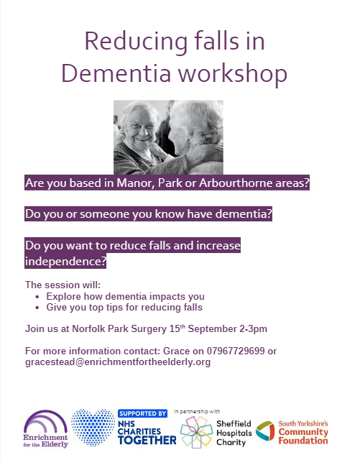 | Health, social care and community colleagues working in the Manor, Park and Arbourthorne areas are taking part in a project to reduce falls amongst people living with dementia.  Several DDG staff and volunteers recently attended this helpful falls training session for staff. This free training is now being offered to people living with dementia and their carers.  Even if you live outside of the area its worth getting in touch as the organisers may be able to extend the invitation to you.
Hype Dance, in association with Lab4Living, and funded by Arts Council England, have undertaken a period of R&D, utilising two dancers and a movement artist / choreographer to understand and deconstruct the movements executed during the dressing of older people in care by re-enacting dressing rituals, using performance research methods.

The aim of this is to explore whether the use of art-based and performance research methods, such as dance and textile creations, can lead to a new understanding of the relationship between a person with reduced mobility and their carers, during dressing rituals.
This project will culminate in a sharing of the dance theatre on Friday 12th August at 19:00 at Hype Dance Studio Theatre, Sheffield. There will be some research materials on display, a short Q&A session after the sharing and a chance for an informal social exchange at the end. The event will last approximately 1 hour.

If you (or any of your colleagues) would like to attend this event, please reply to this email - and please feel free to forward to anyone you feel may be interested. Many thanks Alex

Neighbourhood Dementia Partnership meeting
This is a really useful monthly meeting that I go to which is hosted by Dovercourt surgery. It’s attended by local dementia groups and organisations and has some representation from people living with dementia and carers (but would appreciate more). We often have presentations from local services and people with expertise in living with dementia or supporting people living with dementia. The next meeting is on Thursday 22nd September, 12,30pm-200pm on Zoom. Please contact michelle.wilde1@nhs.net if you would like to be added to the mailing list.

Forthcoming conference organised by Deepness Dementia Media.
At Victoria Hall, Sheffield on the 26th and 27th September 2022
The conference is organised by Deepness Dementia Media (Deepness Ltd), a non-profit organization, run by people living with Dementia for people living with Dementia.
The theme of the two-day Conference is the Unconscious Bias of Dementia
Let me know if you’d like me to send you a copy of the poster or you can get more info from: karen@deepnessdementiaradio.com

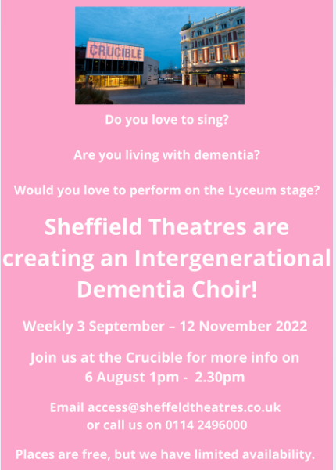 | Chat and Cuppa with Sheffield Museums  Drop-in, free sessions for people living with Dementia or memory issues, their carers and friends. Free tea and coffee provided. These run monthly from the different museum sites and there’s often an opportunity to have a guided tour round the museum/gallery or to do some making yourself. I volunteer at these and it’s a lovely group – it's not well attended yet so please spread the word 😊  Upcoming dates are:  Thursday 11 August 1 – 3pm, Abbeydale Industrial Hamlet  Tuesday 6 September 1 –3pm Kelham Island Museum  More information can be found on their webpage: https://www.museums-sheffield.org.uk/whats-on/events/2022/6/cuppa-at-the-museum-%E2%80%93-dementia-friendly-cafe.

Spotlight On: Manor and Castle Development Trust
One of our local “People Keeping Well” provider organisations is Manor and Castle Development Trust. One of the services they offer is regular wellbeing phone calls/visits to people living with dementia and their carers. Their worker knows about local dementia friendly services and can signpost to other groups or services too. I sat in on their Zoom carers group and also their dementia friendly social café at the Victoria Centre last month – both were very welcoming and I recommend them to you.

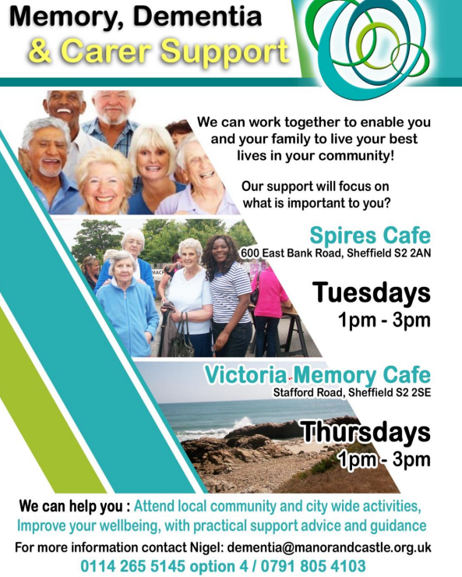

https://manorandcastle.org.uk/health-wellbeing/dementia-support-in-our-community/

Other useful contact numbers
Thank you to Nigel who shared this helpful list of contact numbers
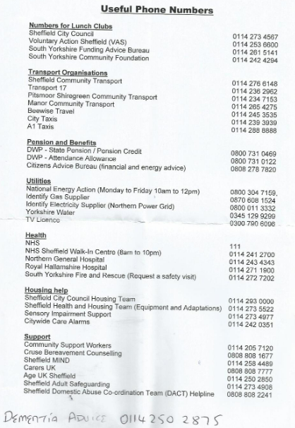

Lastly, as always – if we can help with anything please contact myself or Bev and we will try our best to assist . Also please let me know whether you prefer this newsletter to be posted or emailed or if you would like to come off the distribution list. The newsletter will also be added to our website: http://www.darnalldementiagroup.co.uk/
Thank you! Ayesha
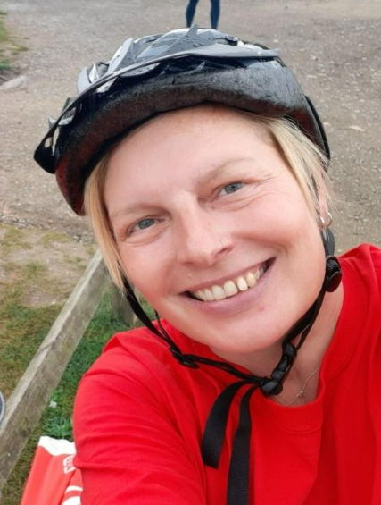  Please contact Ayesha at:  Darnalldementia@yahoo.com or call 07468501570 | 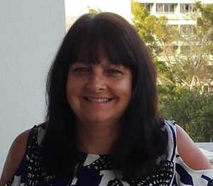  Please contact Bev at:  bevatddg@yahoo.com or call 07397158460

