DARNALL DEMENTIA GROUP
Providing High Quality Person-Centred Care
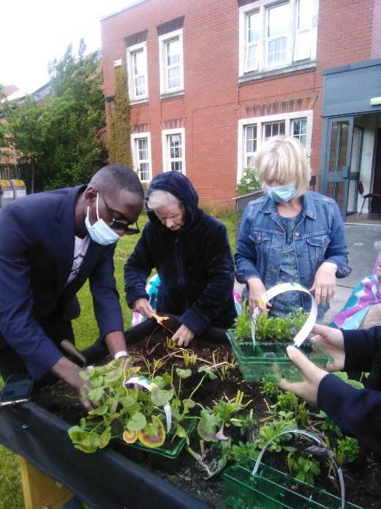

“We’re like a community here – one big family”

Darnall Dementia Group is part of the Darnall Dementia Trust
A Charitable Company Limited by Guarantee
Company Number 8066719
Charity Number 1148094

What is Darnall Dementia Group?
Darnall Dementia Group is a small, community -based organisation, which provides support for people living with dementia & their carers. We have been operating for over 40 years. The organisation is a charitable company run by a small staff team and a committee of trustees.
What does Darnall Dementia Group do?
We provide a day centre for people living with dementia. We deliver the day centre from a church hall in Darnall.
3 days each week the main hall is turned into a comfortable, light & warm space where people living with dementia, volunteers and paid workers can gather to enjoy each other’s company.
The service is delivered by Day Centre Workers, a Day Centre Coordinator and a Service Manager.
A team of dedicated volunteers work alongside the paid workers.

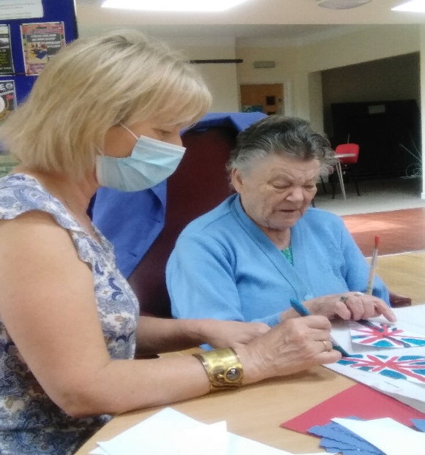
What happens at the Day Centre?
There are 10 places for people living with dementia on Mondays, Wednesdays & Fridays. People can attend on one day, two days or all three days depending on the agreed package of care.
We aim for our group members to receive one to one support so that they can be involved in the decision making and choose whether or not to join in with the group activities. There are always options and members can be involved as much or as little as they like.
We spend time building friendships, chatting and reminiscing, we play board games, we read together or make crafts. Sometimes we play gentle ball games or work in the garden. We especially like listening to music, singing and dancing.
At lunchtime we all eat a hot home-cooked meal together
At the day centre we strive to create a relaxed, informal setting where people have a sense of identity and of belonging. By building a strong community people can develop significant friendships.
Laughter and having a good time are important to us. We want everyone to go home with an increased sense of well-being.
One group member said: “I think what you do is marvellous. I love it here”.
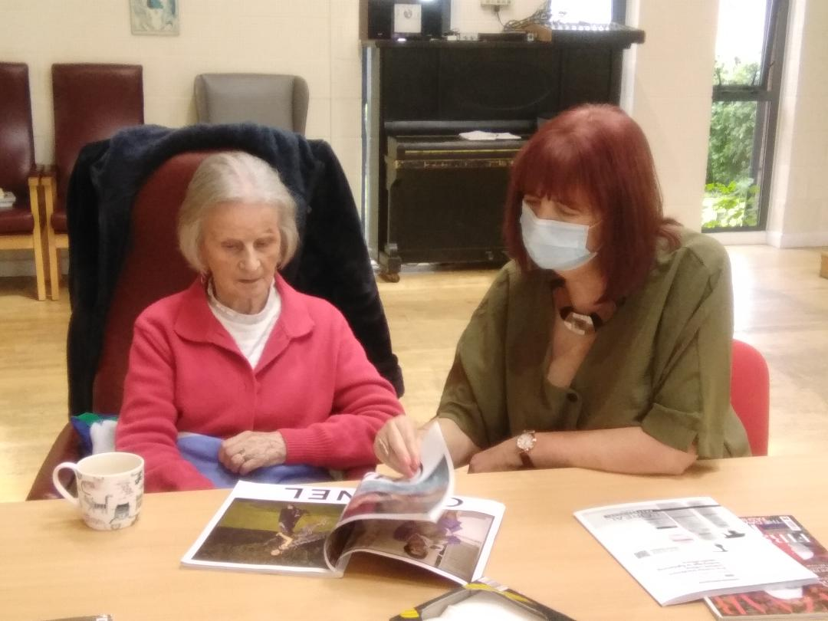
Who can attend?
Darnall Dementia Group is commissioned by Sheffield City Council and all referrals are made through the Social Services team.
We support people who:
- are living with dementia at home (i.e. have a diagnosis of dementia or are in the process of seeking a diagnosis)
AND
- have had a Care and Support Assessment (by the council Social Services Team) and have been described as needing additional help
AND
- live in our catchment area (South/South-East of the city).
Everyone who attends the group has had their financial status assessed and will pay the council for our service. The price depends on their financial circumstances but the maximum anyone can expect to pay is £65 per day (as at February 2022).
We can sometimes offer “private places” to people living outside of Sheffield.
More information about the Council’s Care and Support Assessment can be found on their website here:
https://www.sheffield.gov.uk/home/social-care/getting-long-term-care-support

How do we sign up?
Firstly, the Council team (usually a social worker) will assess the person living with dementia to see if our Day Centre might meet their needs. If they think it can then they will make a referral to us. When we receive the referral we invite the person to come along with a relative or family carer for a cup of tea to visit the day centre to get a better understanding of what we do. Our Day Centre Co-ordinator also visits the person at home so that we can start to get to know them better.
If the person living with dementia likes the service and if everyone involved agrees that we have a good match, then we will offer them a place. If we have no places we will add the persons’ name to a waiting list. We keep in touch with people on the waiting list until it is time for them to start attending.
When a new member starts attending the Day Centre they will be introduced to all the group members and given support to get to know other people and start to enjoy their visits. We spend lots of time building relationships with each individual and their family/carers so that we can make sure we offer activities that match their interests.
If needed, we provide transport for people living within our catchment area of South/South East Sheffield.
What about the carers?
We offer two carers support groups for carers of people currently attending (or who have previously attended) the Day Centre. The online group meets fortnightly on Zoom and the face-to-face group meets monthly at the Church Hall. Those attending the face-to-face group can relax knowing their person is having fun in the Day Centre. Both Carers groups form an important part of the work of Darnall Dementia Group as they provide a safe place for people to share their experiences. The Carers groups give carers an opportunity to meet and learn from each other. Carers have said “it’s been a lifeline for me, my husband coming here” and “he always comes back in a good mood”.
What about volunteering?
We welcome volunteers from all walks of life and with any or no experience of being with people living with dementia. The main attribute we seek in volunteers is an honest commitment to helping people with dementia to enjoy the time they spend with us.

Potential volunteers may want to gain skills to help them get a job or access a university or college course. Or they may want to be involved in something worthwhile and rewarding. We support volunteers to develop their skills and we ensure they can access training, supervision and support throughout their time with us.
Potential volunteers are asked to complete an application form and we seek two references and request a standard DBS check. There is the opportunity to attend for a taster session.
Our volunteering vacancies are advertised on the Sheffield Volunteer Centre website: http://www.sheffieldvolunteercentre.org.uk/i-want-to-volunteer or you can send an email enquiry to: darnalldementia@yahoo.com
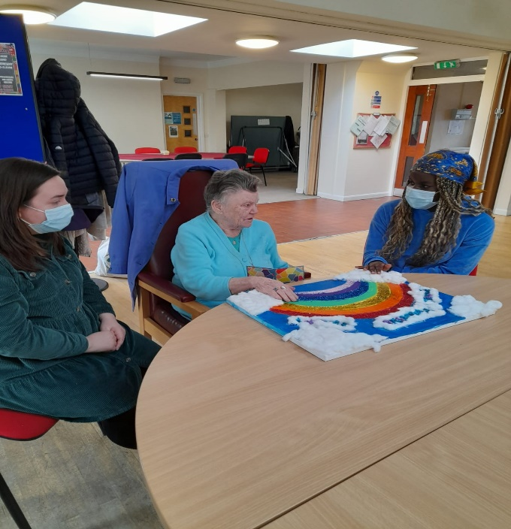
“We’re all happy here – I come because I like it”

Further information
More information about our service can be found on our website here: www.darnalldementiagroup.co.uk
Or please contact us directly:

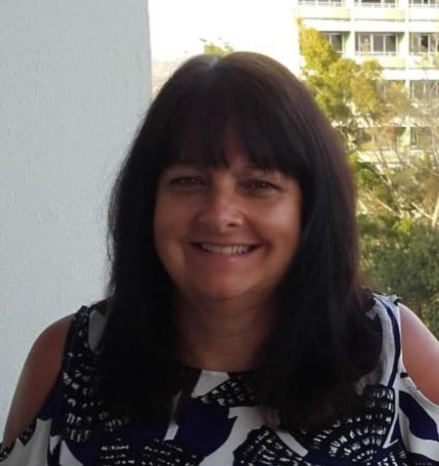
Bev -Day Centre Co-ordinator
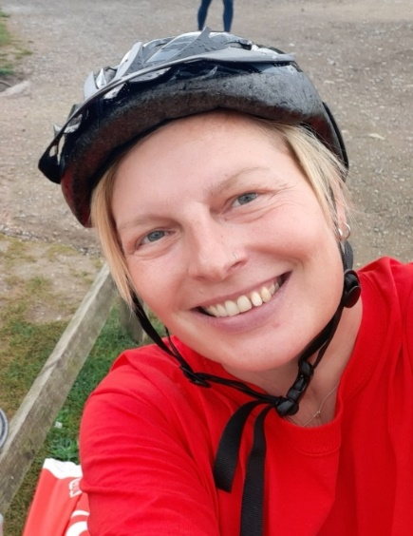
Ayesha - Service Manager
You can call us on: 0114 226 2116
Or email us at: darnalldementia@yahoo.com
Or write to us at: Darnall Dementia Group, Lightwood House, Lightwood Lane, S8 8BG
Twitter: @darnalldementia
If you are interested in making a referral to Darnall Dementia Group please feel free to get in touch for an informal chat first.

