Carers newsletter – May 2022 | 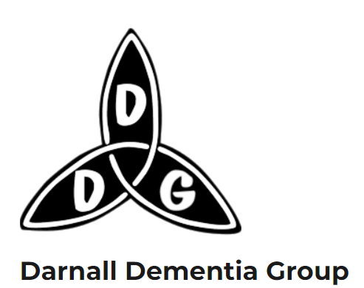

Hello everybody!
Welcome to the first edition of a new newsletter for carers associated with Darnall Dementia Group. There are lots of useful things that it’s good to be able to share in one place – if there’s anything you would like to see included in future issues just let Ayesha or Bev know (contact details at the end).
DDG Groups for carers
We continue to offer two groups for carers past and present. Bev runs a weekly Zoom group on Tuesdays 2pm - 3pm which is a chance to catch up on the week’s events and is well attended. Please call Bev for the Zoom links and log ins.
Ayesha runs a monthly face to face carers group from one of the upstairs rooms at St Albans. It’s a chance to share how we are all getting along but also a chance to share news about groups, events and useful tips. It’s also a chance to meet without the person you care for as they are able to come to a fun (and free) singing session with Andrea downstairs in the Day centre – even if it’s not their regular day to attend. We may be able to help with transport for those living near to Darnall. Please get in touch with Ayesha if you would like to come along and if you would like to book a place for the singing session. Dates for the rest of the year are Wednesday 1 June, 3 August, 7 September, 5 October, 2 November, 7 December

Changes
As you know, the way DDG is funded now has changed with the introduction of the new council contract. This means that people attending our group will have their needs and also their financial status assessed in order for the council to calculate how much they will be charged to attend the day service. It’s a new system for all of us and we are keen to hear about your experiences so we can understand how the system works. If you are happy to share then please get in touch with Bev or Ayesha.

Tips and Tricks!
At our last carers group people were talking about gadgets that you can buy that might be handy – like battery operated motion sensor lights on landings and also a gadget that lights the loo up! I think it might look something like this. I want one!

If you have any handy tips or tricks to share then please tell me about them and I’ll add to the next newsletter.

What’s on?
There are always new groups or events springing up either for people living with dementia or their carers. Here are a few that we’ve come across recently:
New Therapy group for dementia carers dealing with grief and loss during the dementia journey – offered by St Lukes Hospice
Grief therapy is provided for people who have lost someone through death however is not largely available to people who are living with a person that is still alive, for example a person living with dementia.
Through our sessions, we want to open up the conversation around how living with dementia causes a sense of loss and form of grief, and provide carers with an opportunity to share their experiences with a welcoming support group. The groups will be facilitated by a Therapist from the St Luke's Bereavement team alongside a volunteer.
Sessions are Wednesdays 2-4pm at St Lukes, Ecclesall Road South Site. To sign up please contact Viv Huckerby on 0114 235 7505

Neighbourhood Dementia Partnership meeting
This is a really useful monthly meeting that I go to which is hosted by Dovercourt surgery. It’s attended by local dementia groups and organisations and has some representation from people living with dementia and carers (but would appreciate more). We often have presentations from local services and people with expertise in living with dementia or supporting people living with dementia. The next meeting is on Thursday, 26 May 12.30pm – 2.00pm on Zoom. Please contact michelle.wilde1@nhs.net if you would like to be added to mailing list.

Forthcoming conference organised by Deepness Dementia Media.
At Victoria Hall, Sheffield on the 26th and 27th September 2022
The conference is organised by Deepness Dementia Media (Deepness Ltd), a non-profit organization, run by people living with Dementia for people living with Dementia.
The theme of the two-day Conference is the Unconscious Bias of Dementia
Let me know if you’d like me to send you a copy of the poster or you can get more info from: karen@deepnessdementiaradio.com

Tea dances at Beighton Lifestyle Centre  These run on the last Friday of the month 1.30 - 3.30pm. See their website for more info: https://www.beightonlifestyle.co.uk/testpage  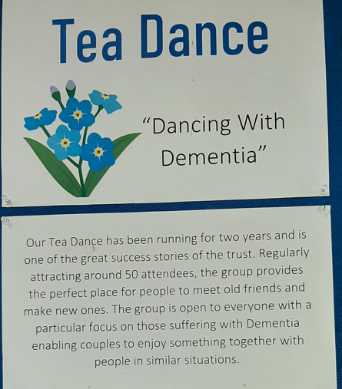 | Chat and Cuppa with Sheffield Museums  Drop-in, free sessions for people living with Dementia or memory issues, their carers and friends. Free tea and coffee provided. These run monthly from the different museum sites and there’s often an opportunity to have a guided tour round the museum/gallery or to do some making yourself.  Upcoming dates are:  Tuesday 7 June 1 – 3pm, Weston Park Museum. Theme: Sheffield Stories  Tuesday 5 July 1 – 3pm, Millennium Gallery. Theme: Let’s Listen and Move  Thursday 11 August 1 – 3pm, Abbeydale Industrial Hamlet  Tuesday 6 September 1 –3pm Kelham Island Museum  More information can be found on their webpage: https://www.museums-sheffield.org.uk/whats-on/events/2022/6/cuppa-at-the-museum-%E2%80%93-dementia-friendly-cafe.

Other services across the city that might be useful
Sheffield Dementia Advice Service – commissioned by the council and delivered by AgeUK
The Dementia Advice Sheffield service provides a one-stop shop, first point of contact service to respond to any non-clinical dementia-related query from a person who is living with dementia or their family carer. Our specialist advice workers will respond to your initial enquiry and signpost you to the best source of information to meet your specific needs, including resources and services in your local community which can provide ongoing support. These may include memory cafes, carers' groups, singing, allotment, chairobics or Sporting Memories groups.
People can contact for anything, but examples may be
- before someone has been to the Memory Service
- Someone has experienced some memory loss
- Someone is concerned about a relative
- Wanting general information
- Someone with Dementia that has noticed it has advanced and have forgotten some of the things that they were told at the time of diagnosis and need some help navigating where to go next

Contact on (0114) 250 2875 or e-mail: dementiaadvice@ageuksheffield.org.uk.
Local People Keeping Well organisations that offer support to people living with dementia and their carers, e.g. SOAR, Zest, Shipshape etc

Follow the link to this helpful leaflet: https://search3.openobjects.com/mediamanager/sheffield/fsd/files/sheffielddementiasupportleaflet2022.pdf or get in touch if you would like me to print and post you a copy. The leaflet also has lots of useful links and tips to other organisations including organisations that support carers and also leaflets about managing with some of the more difficult symptoms of dementia.

Lastly, as always – if we can help with anything please contact myself or Bev and we will try our best to assist . Also please let me know whether you prefer this newsletter to be posted or emailed or if you would like to come off the distribution list. The newsletter will also be added to our website: http://www.darnalldementiagroup.co.uk/
Thank you! Ayesha
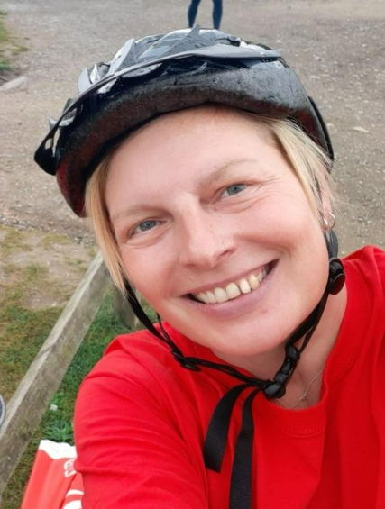  Please contact Ayesha at:  Darnalldementia@yahoo.com or call 07468501570 | 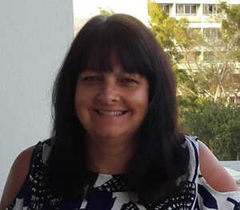  Please contact Bev at:  bevatddg@yahoo.com or call 07397158460

